IN723 Lab 5 - BGP Route Reflectors and Route Filters

Environment: This lab can be completed in VIRL, GNS3 or the physical lab.
Topology
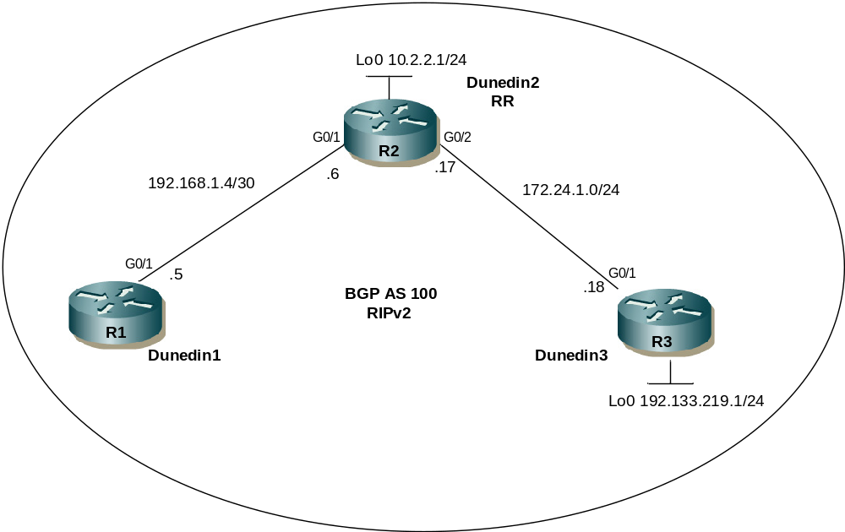
Objectives
- Configure IBGP routers to use a route reflector and a simple route filter.

Background
ACME company maintains a full-mesh IBGP network that has quickly scaled beyond 100 routers. The company wants to implement route reflectors to work around the full-mesh IBGP requirement. Configure a small cluster and observe how BGP operates in this configuration. Use IP prefix filters to control the updates between IBGP peers.

Required Resources
- 3 routers (Cisco 1841 with Cisco IOS Release 12.4(24)T1 Advanced IP Services or comparable)
- Ethernet cables (crossover)
Step 1: Prepare the routers for the lab.
Cable the network as shown in the topology diagram. Erase the startup configuration and reload each router to clear previous configurations. Do not configure Loopback 0 on Dunedin3 at this time.
Step 2: Configure the hostname and interface addresses.
You can copy and paste the following configurations into your routers to begin.
Router R1 (hostname Dunedin1)
hostname Dunedin1
!
interface G0/1
ip address 192.168.1.5 255.255.255.252
no shutdown
Router R2 (hostname Dunedin2)
hostname Dunedin2
!
interface Loopback0
ip address 10.2.2.1 255.255.255.0
!
interface G0/1
ip address 192.168.1.6 255.255.255.252
no shutdown
!
interface G0/2
ip address 172.24.1.17 255.255.255.0
no shutdown
Router R3 (hostname Dunedin3)
hostname Dunedin3
!
interface G0/1
ip address 172.24.1.18 255.255.255.0
no shutdown
Note: Do not configure R3 (Dunedin3) with loopback 0 at this time. That will be done in a later step.
Step 3: Configure RIPv2.
- Build and configure the network according to the diagram. Use RIPv2 as the IGP. Do not configure the 198.133.219.0 network under the RIP process.
Dunedin1(config)# router rip
Dunedin1(config-router)# version 2
Dunedin1(config-router)# no auto-summary
Dunedin1(config-router)# network 192.168.1.0

Dunedin2(config)# router rip
Dunedin2(config-router)# version 2
Dunedin2(config-router)# no auto-summary
Dunedin2(config-router)# network 172.24.0.0
Dunedin2(config-router)# network 192.168.1.0
Dunedin2(config-router)# network 10.0.0.0

Dunedin3(config)# router rip
Dunedin3(config-router)# version 2
Dunedin3(config-router)# no auto-summary
Dunedin3(config-router)# network 172.24.0.0
- Issue the show ip route command on the routers to verify that each router has a complete routing table.
Dunedin1# show ip route
Codes: C - connected, S - static, R - RIP, M - mobile, B - BGP
D - EIGRP, EX - EIGRP external, O - OSPF, IA - OSPF inter area
N1 - OSPF NSSA external type 1, N2 - OSPF NSSA external type 2
E1 - OSPF external type 1, E2 - OSPF external type 2
i - IS-IS, su - IS-IS summary, L1 - IS-IS level-1, L2 - IS-IS level-2
ia - IS-IS inter area, * - candidate default, U - per-user static route
o - ODR, P - periodic downloaded static route

Gateway of last resort is not set

172.24.0.0/24 is subnetted, 1 subnets
R 172.24.1.0 [120/1] via 192.168.1.6, 00:00:21, G0/1
10.0.0.0/24 is subnetted, 1 subnets
R 10.2.2.0 [120/1] via 192.168.1.6, 00:00:21, G0/1
192.168.1.0/30 is subnetted, 1 subnets
C 192.168.1.4 is directly connected, G0/1
- Run the following Tcl script on all routers to verify connectivity.
Dunedin1# tclsh

foreach address {
10.2.2.1
192.168.1.5
192.168.1.6
172.24.1.17
172.24.1.18
} { ping $address }
Step 4: Configure IBGP peers and route reflectors.
In this lab, you will configure a route reflector. By default, a router that receives an EBGP route advertises it to its EBGP and IBGP peers. However, if it receives it through IBGP, it does not advertise it to its IBGP peers, as a loop prevention mechanism. To maintain loop prevention, a route reflector adds two optional, nontransitive BGP attributes to each reflected route, the ORIGINATOR_ID and CLUSTER_LIST. It uses these attributes in a similar way to AS_PATH list to prevent routing loops from occurring. See http://tools.ietf.org/html/rfc4456 for more information.
However, because of this behavior, the only way for all IBGP routers to receive a route after it is originated into the AS is to have a full mesh of IBGP peers. This can get complex with a large number of peers. A route reflector allows a topology to get around the IBGP limitation of having to have a full mesh. To do this, a route reflector specifies some of its neighbors as route reflector clients. When a route reflector receives an update from a route reflector client, it can pass it on to its other clients. The route reflector would also pass that client-learned route on to its other non-client peers (both IBGP and EBGP peers). Similarly, a route learned from a non-client peer (again, from either an IBGP or EBGP peer) would be passed on to its client peers. This greatly simplifies configuration because only the route reflector needs to know all the other peers. The clients do not even know that they are clients. To them, it is just a normal IBGP peering relationship. You can even set up multiple route reflectors in a more advanced configuration for redundancy.
- Configure the IBGP peers for BGP. Later, you will configure Dunedin2 as the route reflector. However, first configure it to peer with both of the other routers.
Dunedin2(config)# router bgp 100
Dunedin2(config-router)# neighbor 192.168.1.5 remote-as 100
Dunedin2(config-router)# neighbor 172.24.1.18 remote-as 100
After Dunedin2 is configured, configure the other two routers as route reflector clients. Remember that to set up clients simply, configure peering between the client and the server. IBGP does not need to be configured in a full mesh.
- Issue the following commands on Dunedin1:
Dunedin1(config)# router bgp 100
Dunedin1(config-router)# neighbor 192.168.1.6 remote-as 100
- Issue the following commands on Dunedin3:
Dunedin3(config)# router bgp 100
Dunedin3(config-router)# neighbor 172.24.1.17 remote-as 100

Note – The actual route reflector configuration is performed on the route-reflector (Dunedin2) and will be completed later

- Use the show ip bgp neighbors command to verify that Dunedin2 has established a peering relationship with both Dunedin1 and Dunedin3. Troubleshoot as necessary.
Dunedin2# show ip bgp neighbors
BGP neighbor is 172.24.1.18, remote AS 100, internal link
BGP version 4, remote router ID 172.24.1.18
BGP state = Established, up for 00:02:10

<output omitted>

BGP neighbor is 192.168.1.5, remote AS 100, internal link
BGP version 4, remote router ID 192.168.1.5
BGP state = Established, up for 00:04:15
Dunedin1 and Dunedin3 should not have established a connection. Why?

Dunedin1 and Dunedin3 were not configured with the appropriate BGP neighbor command. As route reflector clients, Dunedin1 and Dunedin3 do not need to reach an established state.
Step 5: Inject a network into BGP.
- To observe the full effect of using a route reflector, configure Dunedin3 to inject external routing information into BGP.
Dunedin3(config)# interface loopback 0
Dunedin3(config-if)# ip address 198.133.219.1 255.255.255.0

Dunedin3(config-if)# router bgp 100
Dunedin3(config-router)# network 198.133.219.0
This configuration forces Dunedin3 to inject the external route 198.133.219.0 into BGP. Use the show ip route command to check if Dunedin2 has picked up this route through BGP. Dunedin2 should have a route to 198.133.219.0.
Dunedin2# show ip route
Codes: C - connected, S - static, R - RIP, M - mobile, B - BGP
D - EIGRP, EX - EIGRP external, O - OSPF, IA - OSPF inter area
N1 - OSPF NSSA external type 1, N2 - OSPF NSSA external type 2
E1 - OSPF external type 1, E2 - OSPF external type 2
i - IS-IS, su - IS-IS summary, L1 - IS-IS level-1, L2 - IS-IS level-2
ia - IS-IS inter area, * - candidate default, U - per-user static route
o - ODR, P - periodic downloaded static route

Gateway of last resort is not set

172.24.0.0/24 is subnetted, 1 subnets
C 172.24.1.0 is directly connected, G0/2
10.0.0.0/24 is subnetted, 1 subnets
C 10.2.2.0 is directly connected, Loopback0
B 198.133.219.0/24 [200/0] via 172.24.1.18, 00:01:48
C 10.2.2.0 is directly connected, Loopback0
192.168.1.0/30 is subnetted, 1 subnets
C 192.168.1.4 is directly connected, G0/1
What is the next hop for this route? Explain.

- Verify that you can ping 198.133.219.1 from Dunedin2. If not, troubleshoot.
- Check the routing table of Dunedin1. There should not be a route to 198.133.219.0. Why?

- Remember that Dunedin1 is not configured to peer with Dunedin3. To eliminate the need for a full IBGP mesh, Dunedin2 must be configured as a route reflector. Issue the following commands on Dunedin2:
Dunedin2(config)# router bgp 100
Dunedin2(config-router)# neighbor 192.168.1.5 route-reflector-client
Dunedin2(config-router)# neighbor 172.24.1.18 route-reflector-client

*Mar 9 19:02:27.831: %BGP-5-ADJCHANGE: neighbor 192.168.1.5 Down RR client conf
ig change
*Mar 9 19:02:27.931: %BGP-5-ADJCHANGE: neighbor 172.24.1.18 Down RR client conf
ig change
*Mar 9 19:02:32.387: %BGP-5-ADJCHANGE: neighbor 172.24.1.18 Up
*Mar 9 19:02:37.507: %BGP-5-ADJCHANGE: neighbor 192.168.1.5 Up

- Verify that an IBGP cluster was successfully created by issuing the show ip protocols command on Dunedin2. The output of this command should indicate that Dunedin2 is a route reflector.
Dunedin2# show ip protocols
Routing Protocol is "rip"
Outgoing update filter list for all interfaces is not set
Incoming update filter list for all interfaces is not set
Sending updates every 30 seconds, next due in 26 seconds
Invalid after 180 seconds, hold down 180, flushed after 240
Redistributing: rip
Default version control: send version 2, receive version 2
Interface Send Recv Triggered RIP Key-chain
Serial0/0/0 2 2
Serial0/0/1 2 2
Loopback0 2 2
Automatic network summarization is not in effect
Maximum path: 4
Routing for Networks:
10.0.0.0
172.24.0.0
192.168.1.0
Routing Information Sources:
Gateway Distance Last Update
Distance: (default is 120)

Routing Protocol is "bgp 100"
Outgoing update filter list for all interfaces is not set
Incoming update filter list for all interfaces is not set
Route Reflector for address family IPv4 Unicast, 2 clients
IGP synchronization is disabled
Automatic route summarization is disabled
Neighbor(s):
Address FiltIn FiltOut DistIn DistOut Weight RouteMap
172.24.1.18
192.168.1.5
Maximum path: 1
Routing Information Sources:
Gateway Distance Last Update
172.24.1.18 200 00:01:43
Distance: external 20 internal 200 local 200
How many clients does Dunedin2 have?

- Issue the show ip protocols command on Dunedin1. The output of this command does not include information about route reflectors. Remember that Dunedin1 is a client and not a route reflector server, so it is unaware of route reflection.
- Finally, verify that route reflection is working by checking the routing table on Dunedin1. Dunedin1 will have a route to network 198.133.219.0.
Dunedin1# show ip route
Codes: C - connected, S - static, R - RIP, M - mobile, B - BGP
D - EIGRP, EX - EIGRP external, O - OSPF, IA - OSPF inter area
N1 - OSPF NSSA external type 1, N2 - OSPF NSSA external type 2
E1 - OSPF external type 1, E2 - OSPF external type 2
i - IS-IS, su - IS-IS summary, L1 - IS-IS level-1, L2 - IS-IS level-2
ia - IS-IS inter area, * - candidate default, U - per-user static route
o - ODR, P - periodic downloaded static route

Gateway of last resort is not set

172.24.0.0/24 is subnetted, 1 subnets
R 172.24.1.0 [120/1] via 192.168.1.6, 00:00:08, G0/1
10.0.0.0/24 is subnetted, 1 subnets
R 10.2.2.0 [120/1] via 192.168.1.6, 00:00:08, G0/1
B 198.133.219.0/24 [200/0] via 172.24.1.18, 00:01:25
192.168.1.0/30 is subnetted, 1 subnets
C 192.168.1.4 is directly connected, G0/1
Is 172.24.1.18 the IP address of the next hop of this route on the Dunedin1 table? Explain.

Notice that Dunedin1 is not directly connected to the IP network for the next hop. Why?
Hint: From which router did Dunedin1 learn the route?

- Ping 198.133.219.1 from Dunedin1. This ping should be successful.
Notice that Dunedin1 pings to R3 198.133.219.1 are successful even though the next-hop address is not on a directly-connected network. For example, the next-hop address could be 192.168.1.6 on R2 if it were not for the behavior of IBGP.
Step 6: Inject a summary address into BGP.
- For the purpose of this lab, configure Dunedin3 to inject a summary address into BGP.
Dunedin3(config)# router bgp 100
Dunedin3(config-router)# aggregate-address 198.0.0.0 255.0.0.0
BGP should now send the supernet route 198.0.0.0.0/8 to Dunedin2 with the attribute ATOMIC_AGGREGATE set.
Note: By default, BGP on Cisco routers advertises both aggregate routes and the individual component routes. If only the aggregate route is to be advertised, use the aggregate-address network mask summary-only command.
- On Dunedin2, issue the following command:
Dunedin2# show ip bgp 198.0.0.0
BGP routing table entry for 198.0.0.0/8, version 8
Paths: (1 available, best #1, table Default-IP-Routing-Table)
Flag: 0x820
Advertised to update-groups:
1
Local, (aggregated by 100 172.24.1.18), (Received from a RR-client)
172.24.1.18 from 172.24.1.18 (172.24.1.18)
Origin IGP, metric 0, localpref 100, valid, internal, atomic-aggregate, best
According to the output of this command, which address aggregated this route?

What indicates that route reflection is involved in this process?

Is there an indication that the ATOMIC_AGGREGATE attribute has been set?

- Dunedin2 should, in turn, reflect this route to Dunedin1. Check both the routing table and BGP table on Dunedin1 to be sure. Both the route to 198.133.219.0 and the supernet route 198.0.0.0 should be installed in the Dunedin1 routing table and the BGP table.
Dunedin1# show ip route
Codes: C - connected, S - static, R - RIP, M - mobile, B - BGP
D - EIGRP, EX - EIGRP external, O - OSPF, IA - OSPF inter area
N1 - OSPF NSSA external type 1, N2 - OSPF NSSA external type 2
E1 - OSPF external type 1, E2 - OSPF external type 2
i - IS-IS, su - IS-IS summary, L1 - IS-IS level-1, L2 - IS-IS level-2
ia - IS-IS inter area, * - candidate default, U - per-user static route
o - ODR, P - periodic downloaded static route

Gateway of last resort is not set

172.24.0.0/24 is subnetted, 1 subnets
R 172.24.1.0 [120/1] via 192.168.1.6, 00:00:20, G0/1
10.0.0.0/24 is subnetted, 1 subnets
R 10.2.2.0 [120/1] via 192.168.1.6, 00:00:20, G0/1
B 198.133.219.0/24 [200/0] via 172.24.1.18, 00:08:34
192.168.1.0/30 is subnetted, 1 subnets
C 192.168.1.4 is directly connected, G0/0
B 198.0.0.0/8 [200/0] via 172.24.1.18, 00:04:19
ACME has decided to filter specific routes to the 198.0.0.0/8 address space. Configure a route filter to prevent Dunedin2 from sending the 198.133.219.0/24 route to its other clients, in this case to Dunedin1.
- Issue the following commands on Dunedin2:
Dunedin2(config)# ip prefix-list SUPERNETONLY permit 198.0.0.0/8
Dunedin2(config)# router bgp 100
Dunedin2(config-router)# neighbor 192.168.1.5 prefix-list SUPERNETONLY out
- Return to Dunedin1, issue the clear ip bgp * soft command, and verify that the prefix list has done its job by issuing a show ip bgp command. Troubleshoot as necessary.
Unlike before, where routes to 198.133.219.0 and 198.0.0.0 were present, now only one route to 198.0.0.0 in the routing and BGP tables should be seen. Troubleshoot as necessary.
Dunedin1# show ip route
Codes: C - connected, S - static, R - RIP, M - mobile, B - BGP
D - EIGRP, EX - EIGRP external, O - OSPF, IA - OSPF inter area
N1 - OSPF NSSA external type 1, N2 - OSPF NSSA external type 2
E1 - OSPF external type 1, E2 - OSPF external type 2
i - IS-IS, su - IS-IS summary, L1 - IS-IS level-1, L2 - IS-IS level-2
ia - IS-IS inter area, * - candidate default, U - per-user static route
o - ODR, P - periodic downloaded static route

Gateway of last resort is not set

172.24.0.0/24 is subnetted, 1 subnets
R 172.24.1.0 [120/1] via 192.168.1.6, 00:00:20, G0/1
10.0.0.0/24 is subnetted, 1 subnets
R 10.2.2.0 [120/1] via 192.168.1.6, 00:00:20, G0/1
192.168.1.0/30 is subnetted, 1 subnets
C 192.168.1.4 is directly connected, G0/1
B 198.0.0.0/8 [200/0] via 172.24.1.18, 00:04:19
- Run the following Tcl script on all routers to verify full connectivity. All pings should be successful.
Dunedin1# tclsh

foreach address {
10.2.2.1
198.133.219.1
192.168.1.5
192.168.1.6
172.24.1.17
172.24.1.18
} { ping $address }

